Assignment: 3
Q: 1 Explain the method of viewing the contents of hard disk drive using explore option

Ans: Viewing the contents of a hard drive is possible using Windows Explorer, a tool integrated into Windows operating systems since Windows95. The step by step procedure to view contents of a drive is as follows:
    - Click "Start" and select "Computer" to open Windows Explorer.
    - Click "Tools" from the toolbar and select "Folder Options."
    - Click the "View"tab.
    - Click"Show Hidden Files,Folders,and Drives"from the Hidden Files and Folders list as shown below:
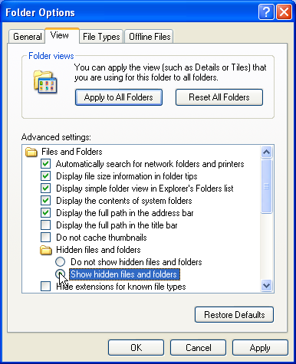
    - Click"Apply",then"OK"to apply the setting changes and exit the window respectively.
Double-click the hard drive under the right panel's Hard Disk Drives list to view its contents. To view files within folders, double-click the folder.

Q:2 Explain the method of finding a file using search option
Ans: Windows offers a number of ways to find files and folders. Search Box offers the most direct way to locate a file. Use 'Search Box' if :
- Click on Start button.You will feed the Search Box located at the bottom of left pane.
- Type either a part or complete name of the file or folder, or type a word or phrase that is present in the file.
- As you type, the items that match your text will appear on the Start menu.
- Click on the desired file/folder, it will open in a newwindow.
- Click on See More Results link to get a detailedlist of searched file/folders. The
Search Results window will open.
Now, just click on a search result to open it.
In case you know only a part of the file name, you can use wildcard characters to locate all files or folders that contain that part in their name. '*' and '?' are two wildcard characters commonly used in searching information.
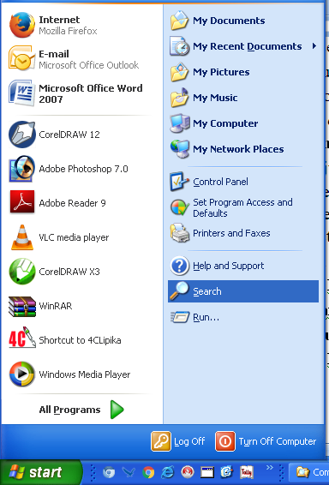

Fig. 2.7 : Search Box
'*' means any type and number of characters in its place.
For Example:
- L*.* will search all files whose names start with 'L' followed by any number of characters and has any extension. E.g., Letter.doc, Lottery.ppt, Locality.txtetc.
- *.doc will search for all the files whose extension is.doc (Wordfiles).
- L*.doc will search for all the files whose extension is.doc and their names begin with the letter'L'.
'?' means any one character in its place. For Example:
- ?,*will search all files whose names contain only one character. E.g., L.doc, R.pps, E.txtetc.
- Kips?.doc will search for all the files whose names begin with 'Kips' followed by any one character and extension is doc.E.g., Kips1.doc, Kips2.doc,etc.
Tip :You can also find a file/folder by clicking the Search box at the top of every window and typing the relevant keyword or text.

SEARCHING AFILE
The step by step method to find a file in Windows XP system is:
    - Click Start, and then click Search.
    - Click All files and folders.
Important :If you do not see All files and folders, you have probably changed your default search behavior.
      - Click Change preferences.
      - Click Change files and folders search behavior.
      - Click Standard, and then click OK.
      - Click All files and folders.
    - Type part or all of the name of the file or folder, or type a word or phrase that is in the file.
    - If you do not know either piece of information or want to narrow your search further, select one or more of the remaining options:
- In Look in, click the drive, folder, or network you want to search.
- Click When was it modified? To look for files that were created or modified on or between specific dates.
- Click What size is it? to look for files of a specific size.
- Click More advanced options to specify additional search criteria.
    - Click Search.
Q:3 Explain formatting a floppy disk using explore option
Ans: Floppy disks usually need to be formatted before you can use them, although some blank floppy disks do come pre-formatted, at some point in the future the user may want to format on his own. The Windows XP operating system makes it easy to format floppy disks. The straightforward process is as follows:
    - Insert the floppydisk.
      - Ensure that the disk is inserted right side-up.
      - Make sure that the disk lock is not engaged before inserting the disk.
      - When formatting a disk, all the information contained on it will be erased, so make sure you've backed up anything you need to save.
    - Click on the START button ,then click on My Computer on the start menu.
    - Right-click on the disk.
    - Left click on the Format option from the menu that appears. A format dialog box will open up.
    - Click Start. A warning, informing that all data on the floppy disk will be deleted, will bepresentedassumingthereisnodataonthefloppythatyouneed,clickOK.
    - The floppy disk will start formatting. When finished clickClose.

The floppy disk is now formatted and can be used to store files.
Q:4 Describe installing new software using control panel
Ans: By using Add or Remove Programs in Control Panel, you can perform a number of tasks-- primarily, the task of installing an application from local media, such as a CD-ROM or floppy disk or the Internet. You can also use Add or Remove Programs to remove or modify an existing application or to repair a damaged application.

Installing a Program:
The following steps need to be taken to install a software/program:
    - Click Start, click Control Panel, and then click Add or Remove Programs.
    - Click Add New Programs, and then click CD or Floppy (To add a program from a CD or floppy disk).
Or
Select the program you want to add, and then click Add (To add a program from a network).
    - As the installer program continues to run and display dialog boxes, click the Next or Continue button.
    - Click the Finish or Close button in the last step of the installer program to complete the process.
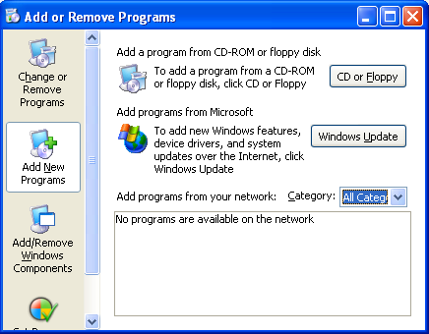

Fig. 2.9 : Installing a Program

Q:5 Describe uninstalling software using control panel
Ans: Uninstalling a Program
The following steps need to be taken to uninstall/update a software/program:
- Click Start, click Control Panel, and then click Add or Remove Programs.

Click Change or RemoveP rograms.
- Click the program you want to change orremove.
- To change a program , click Change/Remove or Change. Or
To remove a program, click Change/Remove or Remove.

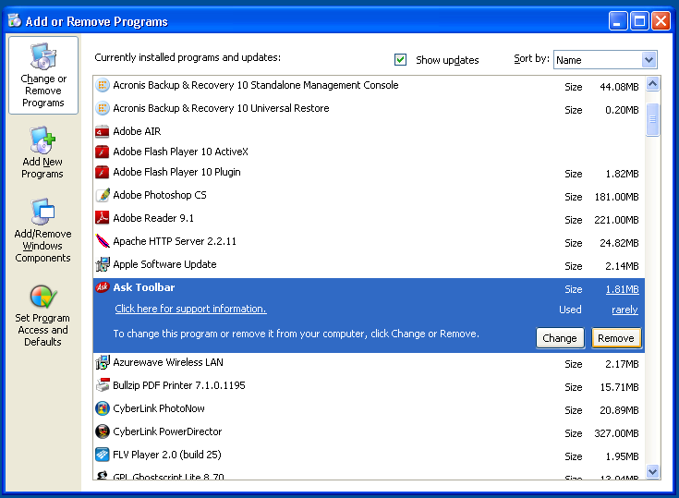

Fig. : Uninstalling a program

Q:6 Explain installing a new hardware using control panel
Ans: HARDWARE INSTALLATION
It is possible to add new physical components to our computer like a modem or a new monitor, just to name a few examples. For the new component to work, our operating system needs to detect it. Usually ,Windows will detect the new hardware automatically, but in the event that it does not, Windows provides us with the tool Printers and Other Hardware in Control Panel that lets us install the new hardware correctly.
The following steps need to be taken to install a hardware:
    - Click Start, click Control Panel, and then click Printers and Other Hardware and a screen like the one below wil lappear:

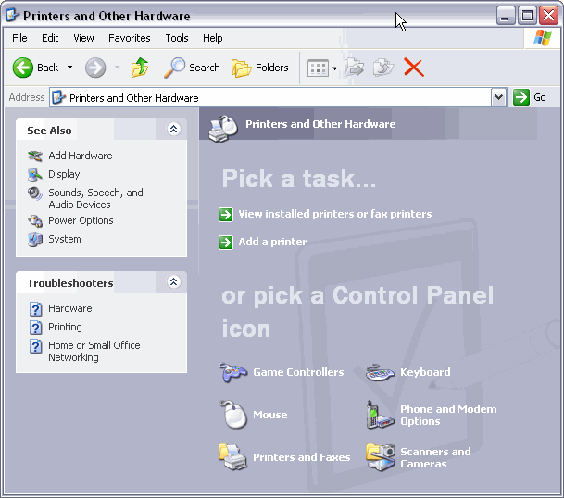
    - Now click on Add hardware. A dialogbox AddHardwareWizard will get opened.
    - Click the Next button each time as asked by the dialog box until the hardware is installed.
    - Click the Finish button or press Enter to finish installing the new hardware.

Q:7 Explain uninstalling a hardware using control panel

Ans: HARDWARE UNINSTALLATION
    - Click Start, and then click Control Panel.
    - Click Performance and Maintenance, and then click System.
    - On the Hardware tab, click Device Manager. Device Manager window will open up as shown below:
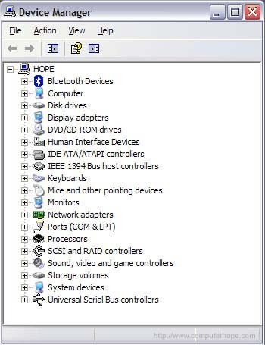

Once in Device Manager click the '+' symbol or arrow next to the device type you want to remove. For example, If you are looking for the video card you would click the '+' next to Display adapters to view each of the video cards installed in the computer.
Finally, highlight the device you want to remove and press the delete key on your keyboard or click Action from the File Menu and then Uninstall.

Q:8 Narrate finding out drive space using system tool option of accessories group

Ans: SYSTEMTOOLS
It's important to perform some basic maintenance from time to time to keep Windows XP running smoothly. Windows XP provides you with some basic tools to make the maintenance process as painless as possible. You can access these tools via the System Tools menu.
To open the System Tools menu:

ChooseStart AllPrograms Accessories SystemTools.
    - A cascading System Tools menuopens.

Finding Drive Space
To find the drive space through system tools:
- Go to Computer in System Tools. Explorer window will get opened.
- Right Click the C: or D: Drive and select Properties.
- Under the General Tab, used and free space is shown clearly.

Q:9 Explain the procedure of disk defragmentation using system tool

Ans: DISKDEFRAGMENTATION
All Windows XP computers have at least one hard disk. The hard disk acts as the computer'sstoragearea.Almosteverythinginstalledonthecomputer—applications,files, folders, and the operating system—is stored here.
With general use (creating new files, deleting files,or installing new software),thehard disk can become fragmented. This means parts of the same disk file become scattered over different areas of the disk.A fragmented hard disks slows down your computer and hinders its performance.To keep the hard disk running smoothly, the user must routinely defragment, or "defrag" the hard disk. The Disk Defragmenter tool can help you do this.
To use Disk Defragmenter:
    - Close all programs that are running. This includes background programs such as scanners.
    - Click Start,Programs orAll Programs, Accessories, and then click System Tools.
    - Click Disk Defragmenter and follow the on-screen instructions.
If Disk Defragmenter starts repeatedly, a hidden background program is still accessing the hard drive. Restart the computer in Safe mode and try again.

Q:10 Narrate installing a Printer using control panel
Ans: PRINTER INSTALLATION
Adding a printer to your computer involves two steps: making the connection from the computer to the printer using either a parallel or USB cable, and installing the software needed to allow your computer to communicate with the specific printer you want to use. This software is often supplied on a disk by the printer’s manufacturer, but most printers will work with the drivers supplied with Windows XP. The driver software provided by the manufacturer may add extra features, such as giving you information about the ink levels.
To install a new printer with Windows XP’s Add Printer Wizard, follow these steps:
Click the Start button on the Windows taskbar and then click ControlPanel.
Click the Printers and Other Hardware hyperlink if the Control Panel window is in Category View. Otherwise, double-click the Printers and Faxes icon if the Control Panel window is in Classic View.
Click on the AddaPrinter hyper link in the Printers and Other Hardware window to start the Add Printer Wizard and then click the Next button or press Enter to advance to the Local Printer or Printer Connection dialog box. If you are in Classic View, start the wizard by clicking on the AddaPrinter option on the left,underPrinter Tasks.
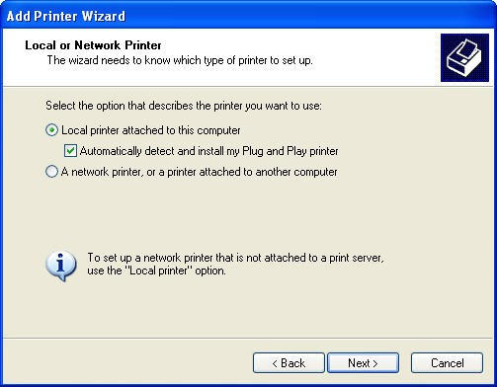
Make sure that the Add Printer Wizard selects the LocalPrinter radiobutton,and that the Automatically Detect and Install my Plug and Play Printer check box beneath this radio button is also selected before you click the Nextbutton.
    - Follow the instructions on the screen to finish setting up the printer by selecting a printer port, selecting the manufacturer and model of your printer, and typing a name for yourprinter.

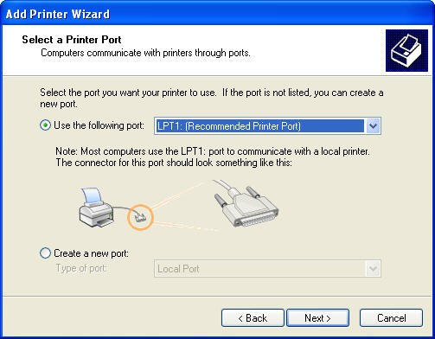
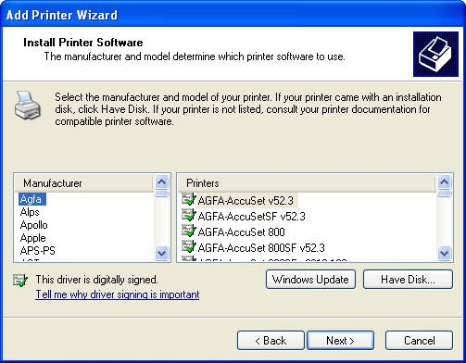
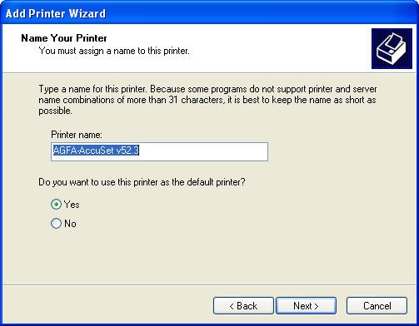

Q: 11 Explain the procedure for changing resolution, colour, appearances, and screen saver option of the display.

Ans: CHANGING THE DESKTOPBACKGROUND
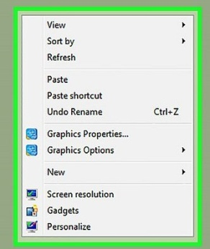
You enjoy working with Windows as it is user friendly. You can change the appearance of the desktop background according to your choice.
- Right-click anywhere on the desktop.
- You will find the list of options.
- Select the Personalize option.
- The Personalization dialog box wil lappear.
- Click on Desktop Background.
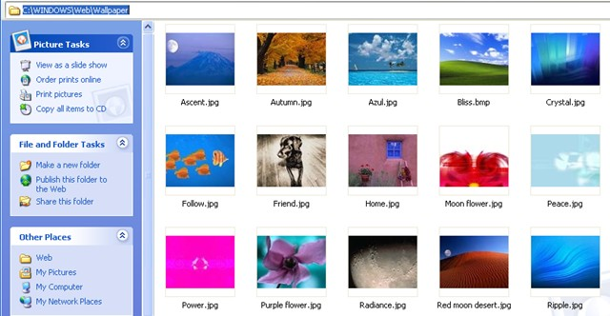
- A new window with multiple images will appear.

Fig. 2.11 : Changing Wallpaper
- Select any background from the displayed list.
Tip :Under Choose your desktop background option, you can select one picture for Desktop Background or select more than one picture to create a Slide Show.
- A preview of the selected background will appear on the monitor.
- After selecting the background, click on Save changes button ,and close the dialog box.

CHANGING THE SCREENSAVER
Screen Saver is an image which pops up on the computer screen whenever the computer remains idle for a short time. By pressing any key, you can get back to the normal screen again. To change the screen saver, follow these steps:
- Right-click on the blank area of the desktop.
- Click on the Personalize option from the Short cut menu.
- The Personalization dialog box will appear.
- Click on the ScreenSaver option.The'ScreenSaver Settings' dialogbox will appear.

- Click on the drop-down arrow in Screen saver section, and select screen saver of your choice.
- A mini preview of the screensaver will be displayed in the Preview box.
- To watch the preview on full screen, click on the Preview button. Wait for a few seconds and you will get the preview on the fullscreen of the selected screensaver.
- Move the mouse to come back to the Screen SaverSetting window dialogbox.
- Change the time in Wait box as per your need. Use up arrow to increase the time and down arrow to decrease.
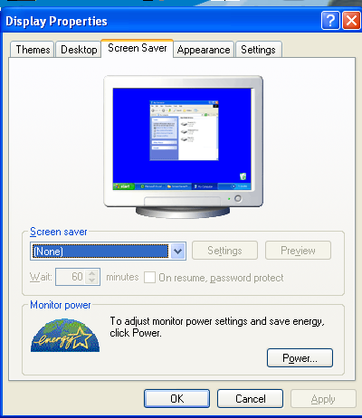
- Click on Apply, and then OK button.

Fig. 2.12 : Changing the Screen Saver

CUSTOMIZING THEDESKTOP
Windows is quite flexible and provides options to change the settings of Desktop according to your choice. Follow the steps to change the colour scheme of the computer screen:
- Right-click on the blank area of desktop and select the Personalize option. The
Personalization dialog box will appear.
- Click on the WindowColor option, located at the bottom of the dialog box.Select any colour to change the window borders, Start menu and taskbar.
- Select Enabletransparency option, the windows glass borders, Start menu and taksbar will become transparent.

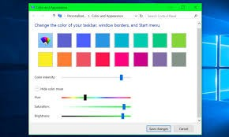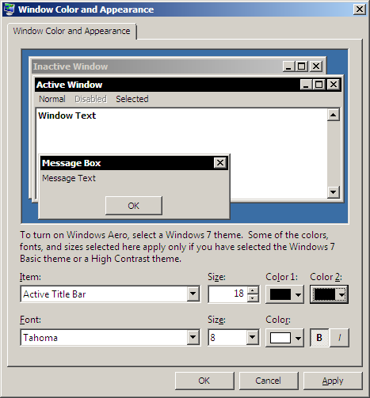

Fig. 2.13 : Changing Desktop Appearance
- Set the Color intensity option, it will effect on window glass borders, Start menu and taskbar's colour strength.
- Click on Showcolormixer option to set the Hue,Saturation and Brightness option to give colour effect.
- Click on the Advanced appearance setting option. Window Color and Appearance
dialog box will open.
- Click on the drop-down arrow at Itemlist box and select ActiveTitleBar option from the list.Now,click on the Color list box and select any colour of your choice.
- Similarly,click on Font listbox and change the font settings.Click on OK button.
- You will find a change in the appearance of window. Click on Apply button, and then click onOK.

Q12: Narrate the process of charging the system date and time

Ans: CHANGING DATE ANDTIME
This option allows you to change the computer's date and time.
- Click on the DateandTime option in, ControlPanel.TheDateandTime dialog box will appear.
- By default, the Date and Time tab is selected.
- Click on Change date and time tab. The Date and Time Settings dialog box will appear.
- Select the current day in the displayed calendar. You can change the month using the forward/backward arrow buttons present in the calendar. Clickon OK button.

To Change Time
- To change the hour, select the hour in the text box, and then click on the arrows to increase or decrease the hours accordingly.
- Similarly, you can change the minutes and seconds.

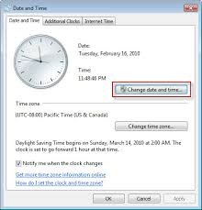

Fig. 2.14 : Date and Time Settings

