Assignment UNIT 3

Q 1 Explain meaning of a computer network

Computer Network
- A computer network is a system in which multiple computers are connected to each other to share information and resources.
- The physical connection between networked computing devices is established using either cable media or wireless media.
- The best-known computer network is the Internet.
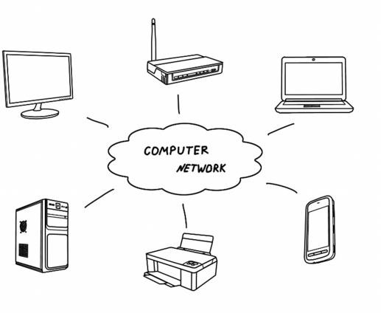
Computer Network

Q2 : Give advantages of computer networks
Advantages of Computer Networks

File sharing
The major advantage of a computer network is that is allows file sharing and remote file access. A person sitting at one computer that is connected to a network can easily see files present on another computer, provided he is authorized to do so.

Resource sharing
All computers in the network can share resources such as printers, fax machines, modems, and scanners.

Better connectivity and communications
It allows users to connect and communicate with each other easily. Various communication applications included e-mail and groupware are used. Through e-mail, members of a network can send message and ensure safe delivery of data to other members, even in their absence.

Internet access
Computer networks provide internet service over the entire network. Every single computer attached to the network can experience the high speed internet.

Entertainment
Many games and other means of entertainment are easily available on the internet. Furthermore, Local Area Networks (LANs) offers and allows other ways of enjoyments, such as many players are connected through LAN and play a particular game with each other from remote location.

Q 3: Give difference between Local area network and Wide area network
LAN
1. LAN (Local Area Network) is a computer network covering a small geographic area, like a home, office, schools, or group of buildings.
2. LAN has high speed (upto 1000mbps)
3. The best example for a LAN is the network in an organization.
4. The LAN is build using the layer 2 devices like switches, bridges and layer1 devices like hubs.
5. LAN is owned, controlled, and managed by a single person or organization
6. LAN is easier to maintain at relatively low costs.
7. LAN experiences fewer data transmission errors

WAN
1. WAN (Wide Area Network) is a computer network that covers a broad area.
2. WAN has less speed (upto 150mbps)
3. The best example for a WAN is the Internet
4. The WAN is build using the layers 3 devices Routers and Multi-layer Switches.
5. WAN's are not owned by any one organization but rather exist under distributed ownership.
6. Maintaining WAN is difficult because of its wider geographical coverage and higher maintenance costs.
7. WAN experiences more data transmission errors.

Q4 : Compare internet & intranet
Internet
1. Internet is wide network of computers and is open for all.
2. Internet itself contains a large number of intranets.
3. The number of users who use internet is Unlimited.
4. The Visitors traffic is unlimited.
5. Internet contains different source of information and is available for all.
Intranet
1. Intranet is also a network of computers designed for a specific group of users.
2. Intranet can be accessed from Internet but with restrictions.
3. The number of users is limited.
4. The traffic allowed is also limited.
5. Intranet contains only specific group information.

Therefore the Internet is an open, public space, while an intranet is designed to be a private space. An intranet may be accessible from the Internet, but it is protected by a password and accessible only to authorized users.

Q 5 Describe the role of an internet service provider
An Internet service provider (ISP), also sometimes referred to as an Internet access provider (IAP), is a company that offers its customers access to the Internet.
The ISP connects to its customers using a data transmission technology such as dial-up, DSL, cable modem, wireless or dedicated high-speed interconnects.
ISPs also provide Internet e-mail accounts to users which allow them to communicate with one another by sending and receiving electronic messages through their ISP's servers.
As part of their e-mail service, ISPs usually offer the user an e-mail client software package, developed either internally or through an outside contract arrangement.
ISPs may also provide other services such as remotely storing data files on behalf of their customers, as well as other services unique to each particular ISP.

Q6: Explain the role of the modem in accessing the internet
Modem stands for MOdulator/DEModulator. A modem converts digital signals generated by the computer into analog signals which can be transmitted over a telephone or cable line and transforms incoming analog signals into their digital equivalents.
A modem is a very important hardware that allows a computer to send and receive data through a telephone line or cable connection. In simple words, it’s the device that connects a computer to the Internet.
Q7: Explain the installation procedure of a modem using control panel
You can install a modem manually by connecting it an empty communication port (COM 1, COM 2) etc , the following is the method for this -

In the Start Menu, click the Control Panel, it will open the window of the control panel on your screen. Double click on the Phone and Modem option icon in this window. This will open the dialog box.
In the dialog box, select the Modem tab and click on the add button

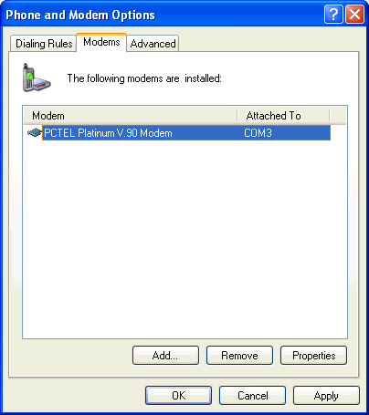

By doing so, the first dialog box will open for you to install Modem.
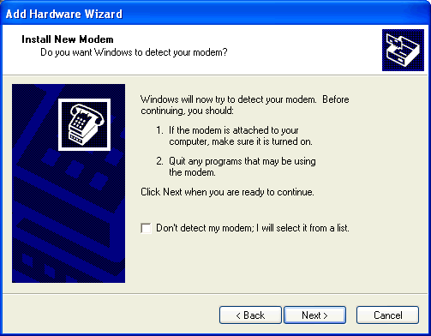

In the dialog box If do not detect my modem, select the option and click on the next button. This will open the second dialog box to install Modem.
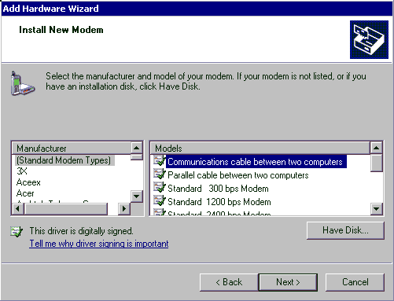
In this dialogue box, the list of companies that make the modem on the left and a list of their available model on the right is given.
If you have a CD to install your modem, then put it in the computer and click on the disk button in the dialog box. By doing this, the install from disk dialog box will be opened.
In this dialog box, the modem you select is displayed and in the list box you have to select the name of the port from which the modem has been added, then click on the next button, after which the last dialog box will appear on the screen.
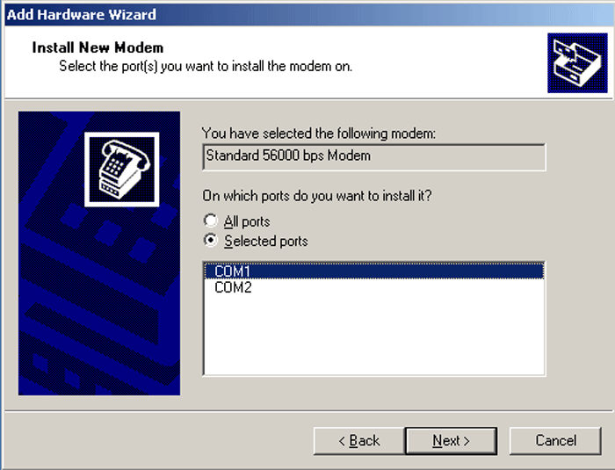
in this dialog box, click the Finish button and the modem will be installed and its name will be displayed in the modem tab sheet.
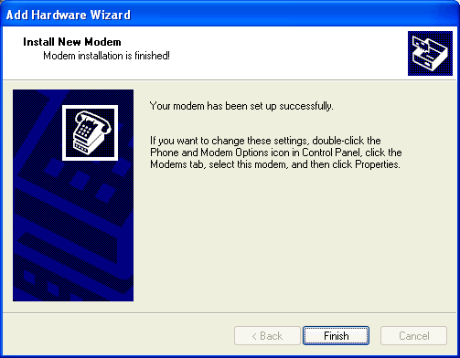
Q8: Explain the purpose of web browser software
A web browser is the software program, used to access the World Wide Web. A browser (also known as client software) retrieves data from remote web servers and displays a web page.
Through this tool the user send their request to Internet server to access the information, Server process the request and responds with required information as a web page to the user.
The most popular browsers are Internet Explorer, Google Chrome and Netscape Navigator.
Q9: write steps for connecting to a website using web browser.
The steps for connecting to a website are shown in and explained further.
- Types a URL for a website in browser say http://kcgpwamb002.edu.in/
- Your browser attempts to make a connection and sends the request to Web Server.
- The Web Server receives and processes the request.
- The Web Server responds to the request with the home page of the website.
- The webpage is displayed by your browser and the connection between the server and your browser is closed

Q 10:Explain the structure of a Universal Resources Locator(URL)
URL stands for Uniform Resource Locator or Universal Resource Locator. A URL is a specific character string that constitutes a reference to an Internet resource.

What is URL
URL is the global address of documents and other resources on the World Wide Web. Its main purpose is to identify the location of a document and other web resources available on the Internet, and specify the mechanism for accessing it through a web browser.
For example see the following URL
https://www.kcgpw.com/tutorial/html-url.php

The URL Syntax
The general syntax of URLs is the following:
scheme://host:port/path?query-string
A URL has a linear structure and normally consists of some of the following:
- Scheme name — The scheme identifies the protocol to be used to access the resource on the Internet. The scheme names followed by the three characters :// (a colon and two slashes). The most commonly used protocols are http://, https://.
- Host name — The host name identifies the host where resource is located. A hostname is a domain name assigned to a host computer. For example, www.kcgpw.com consists of host's machine name www and the domain name kcgpw.com.
- Path — The path identifies the specific resource within the host that the user wants to access. For example, tutorial/html-url.php
- Query String — The query string contains data to be passed to server-side scripts, running on the web server. For example, parameters for a search. The query string preceded by a question mark, is usually a string of name and value pairs for example, ?q=example%20

Q11: Describe the purpose of World Wide Web, FTP, telnet and E-mail
1.WWW: World Wide Web (WWW): The World Wide Web (“WWW” or simply the “web”) is a collection of electronic documents (called web pages) that are linked together like a spider web. These documents are stored on computers called servers located around the world.

2. FTP: What is FTP? One of the most popular uses of the Internet is to download files - that is, transfer files from a computer on the Internet to your computer.
Many thousands of files are downloaded every day from the Internet. Most of these files are downloaded using the Internet's File Transfer Protocol, commonly referred to as FTP. This protocol can also be used to upload files from your computer to another computer on the Internet.

Definition of FTP (File Transfer Protocol)
File Transfer Protocol is a standard network protocol used to exchange and manipulate files over a TCP/IP-based network, such as the Internet

3. Telnet: Telnet is a protocol (set of rules) that allows you to connect to remote computers (called hosts) over a TCP/IP network (such as the internet).
Using telnet client software on your computer, you can make a connection to a telnet server (that is, the remote host). Once your telnet client establishes a connection to the remote host, your client becomes a virtual terminal, allowing you to communicate with the remote host from your computer. In most cases, you'll need to log into the remote host, which requires that you have an account on that system. Occasionally, you can log in as guest or public without having an account.
4. E-Mail (Electronic Mail)
E-Mail or Electronic Mail is a paperless method of sending messages, letters, video and graphics from one person to another or many people at the same time via Internet. E-mail is very fast, easy and much cheaper than the using the post office, takes only few seconds to arrive at the destination.
There are many free web-based e-mail services available on the Internet. A few among them are:
YAHOO! Mail (http://www.mail.yahoo.com),
Gmail(http://www.gmail.com),
Rediffmail (http://www.rediffmail.com) , etc.

Q12: Explain the process of sending and receiving e-mail

Ans: E-mail System
E-mail system comprises of the following three components:
- Mailer
- Mail Server
- Mailbox

Mailer
It is also called mail program, mail application or mail client. It allows us to manage, read and compose e-mail.

Mail Server
The function of mail server is to receive, store and deliver the email. It is must for mail servers to be running all the time because if it crashes or is down, email can be lost.

Mailboxes
Mailbox is generally a folder that contains emails and information about them.

Working of E-mail
Email working follows the client server approach. In this client is the mailer i.e. the mail application or mail program and server is a device that manages emails.
- Suppose person A wants to send an email message to person B.
- Person A composes the messages using a mailer program i.e. mail client and then select Send option.
- The message is routed to Simple Mail Transfer Protocol to person B’s mail server.
- The mail server stores the email message on disk in an area designated for person B.
The disk space area on mail server is called mail spool.
- Now, suppose person B is running a POP client and knows how to communicate with B’s mail server.
- It will periodically poll the POP server to check if any new email has arrived for B. A is in this case, person A has sent an email for person B, so email is forwarded over the network to B’s PC. This is message is now stored on person B’s PC.

The following diagram gives pictorial representation of the steps discussed above:
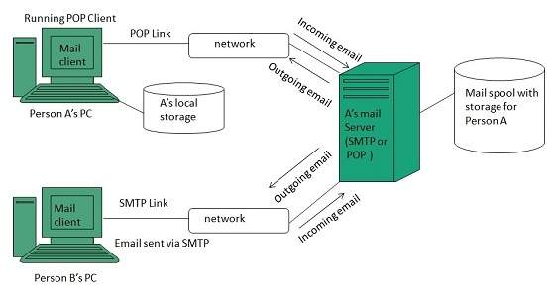

Q:13 what are different connections that allows you to connect with the internet?
- Dial-up
This is the most common basic type of connection available from ISPs (Internet Server Providers). In Dial-up connection, you use your computer, dial a phone number (provider by ISP) to get connected to server at Providers end through which you access Internet. It means you are not directly connected to Internet; you access the Internet through an Internet Service Provider.

- ISDN (Integrated Services Digital Network)
The process of connecting to server to access Internet is almost same as Dial-up, but it offers connectivity through the use of digital phone lines instead of Analog. It offers Internet connectivity at speeds of up to 128 Kbps, allows the user to receive or make calls simultaneously on the same line. ISDN comes through a regular telephone wire from the telephone pole on the street. The line combines two 64 Kbps channels to offer 128 Kbps bandwidth broken into three bands: One band for the ringing signal of your phone, one band for your telephone conversation, and one band for data transfer.
- Leased Line Connection (Direct Internet Access)
A “permanent connection” between a computer system (single CPU or LAN, and the Internet). It is generally used by larger institutions, corporate and government agencies. It involves establishing your own Internet gateway (connection) and payment to have a direct full time line with the network. Your computers, in effect, become part of the Net. The main advantage of this connection is that: it is on line – 24 hrs a day, seven days a week, (24x7) and provides faster access.
Dedicated links are established through an internet service provider who places a computer-controlled router (message director) at your site. A router is used to connect your local network to the Internet, allow all the members of network to have complete access to Internet.
- DSL (Digital Subscriber Line or Dedicated Service Line) Broadband Connection
DSL, an “always-on’ data connection is becoming widely available these days. It can provide an excellent Internet connection. It connects your home or office to the Internet through the same telephone wire that comes from telephone pole on the street. Like ISDN, with DSL, user can make and receive telephone calls while connected to the Internet. The difference between DSL and dial- up / ISDN is that a DSL Internet connection uses a high-speed dedicated circuit filtering out standard phone calls and Internet signals.

Q 14: Describe address format and IP address
IP (Internet Protocol) Address: Computers do not understand letters or symbols that humans use to communicate effectively. Computers understand numbers-specifically, 1s and 0s. Thus every host (a computer linked to the Internet) on the Internet has a unique host number. This number is called the Internet Protocol address, or IP address.
The IP address is a unique address, generally written in the format xxx.xxx.xxx.xxx, where xxx represents a 3 digit number that varies between 0 and 255. For Example: 192.100.8.56

Q 15 :Describe Domain Name System
DNS (Domain Name System): Every host (computer linked to Internet) has a unique host number called IP address. You can connect to any host through IP address only, but it is difficult to remember the 4-digit number of hosts. To resolve this, domain- name is the only solution. Domain name, a unique name of the individual host computer on the Internet. Every computer on the Internet now have both a domain name and an IP address. To connect to any host through domain name requires some mechanism that will convert the domain name IP address. DNS, Domain Name System is the standard for resolving names to addresses. It is used mostly to translate between domain names and IP addresses.

Q 16: Describe the role of search engines with examples

Search Engine:The Internet is an amazing resource that provides quick access to all sorts of information. The amount of information, however, is so vast that being able to find what you are looking for is a difficult task. Search engines are the solution to this problem.
A search engine is a program designed to help find information stored on a computer system such as the World Wide Web, or a personal computer. The search engine allows one to ask for content meeting specific criteria (typically those containing a given word or phrase) and retrieving a list of references that match those criteria.

Some of the important search engines are:
Google (http://www.google.com ), Yahoo (http:// www.yahoo.com), MSN Search (http://search.msn.com), Ask Jeeves (http://www.askjeeves.com), AltaVista (http:// www.altavista.com)

Q17:What is the difference between search engines and directory?
A search engine, such as Yahoo or Google, is an online tool that helps users of the Internet find the sites and information they're looking for. Most search engines use automated programs (sometimes called spiders) to look for relevant information based on keywords entered by the user.
A search directory is a catalog of websites organized by category to allow users to easily browse for the information they need. Unlike search engines, which locate and display relevant information based on a formula or algorithm using an automated software program, search directories are organized by real people who discover new sites and relevant information by exploring the Internet themselves and by reviewing submitted sites.

Q18: Describe Social network. Give examples of Social networking sites.
Social Network: Alternatively referred to as a virtual community or profile site, a social network is a website that brings people together to talk, share ideas and interests, or make new friends. This type of collaboration and sharing is known as social media. Unlike traditional media that is created by not more than ten people, social media sites contain content created by hundreds or even millions of different people.
Below is a small list of some of the biggest social networks used today.Examples of social networks
- Facebook ( https://www.facebook.com/ ) - The most popular social networking websites on the Internet. Facebook is a popular destination for users to set up personal space and connect with friends, share pictures, share movies, talk about what you're doing, etc.
- Google+ (https://plus.google.com/) - The latest social networking service from Google.
- Instagram ( https://www.instagram.com/ ) - A mobile photo sharing service and application available for the iPhone, Android, and Windows Phone platforms.
- Pinterest ( https://www.pinterest.com/ ) - A popular picture and sharing service that allows anyone to share pictures, create collections, and more.
- Twitter ( https://twitter.com/ ) - Another fantastic service that allows users to post 140 character long posts from their phones and on the Internet. A fantastic way to get the pulse of what's going on around the world.
- YouTube ( https://www.youtube.com/ ) - An excellent network of users posting video blogs and other fun and exciting videos.

Q:19 Understand internet security
Internet Security:
Internet security is a branch of computer security that deals specifically with Internet-based threats. These include hacking, where unauthorized users gain access to computer systems, email accounts or websites; viruses and other malicious software (malware), which can damage data or make systems vulnerable to other threats; and identity theft, where hackers steal personal details such as credit card numbers and bank account information. You can protect yourself from these threats with strong Internet security.

Threats
Internet security threats impact the network, data security and other internet connected systems. Cyber criminals have evolved several techniques to threat privacy and integrity of bank accounts, businesses, and organizations.
Following are some of the internet security threats:
- Mobile worms
- Malware
- PC and Mobile ransomware
- Large scale attacks like Stuxnet that attempts to destroy infrastructure.
- Hacking as a Service
- Spam
- E-mail-Phishing

